Task5:

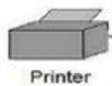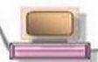

B

Internet

to internet connection

A

Ethernet switch or hub

# Wired Channel:

Wired channels offer better performance compared to wireless channels, it is more secure than wireless communication in terms of information penetration and the bandwidth of a wired connection is much higher than wireless communication.

# Ethernet:

Ethernet internet protocol uses the Ethernet infrastructure to manage the

connection between various automation devices such as robots, PLCs, sensors, CNCs and other industrial machines.